**Lecții on-line educație tehnologică și aplicații practice**

**1**.Carmen Pavel is inviting you to a scheduled Zoom meeting.

Topic: Protectia consumatorului

Time: Apr 29, 2020 12:00 PM Bucharest

Join Zoom Meeting

https://us04web.zoom.us/j/74181463911

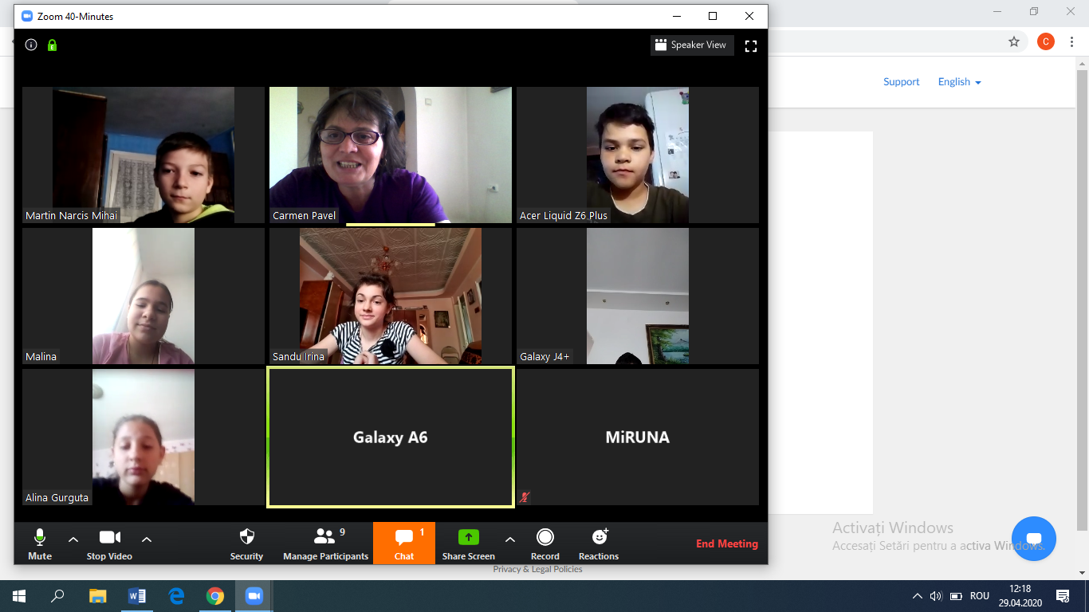

**2**.Carmen Pavel is inviting you to a scheduled Zoom meeting.

Topic: Ed.tehnologică VI A- Locuința

Time: Apr 28, 2020 02:00 PM Bucharest

Join Zoom Meeting

https://us04web.zoom.us/j/72664456431

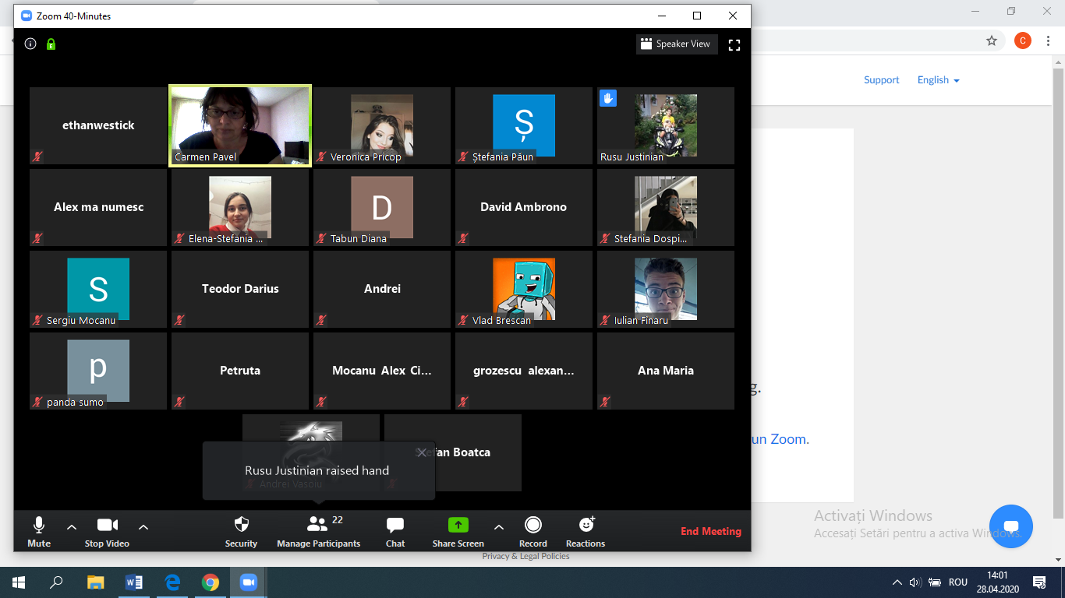

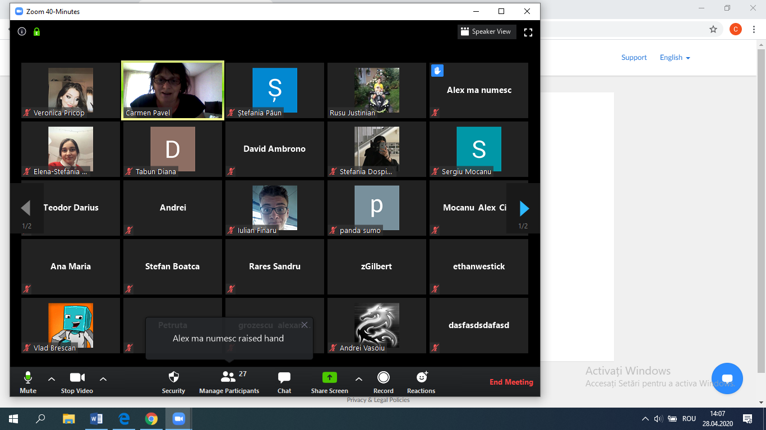

**3**.Carmen Pavel is inviting you to a scheduled Zoom meeting.

Topic: ed.tehnologică-Cauciucul

Time: Apr 28, 2020 12:00 PM Bucharest

Join Zoom Meeting

https://us04web.zoom.us/j/73244576676

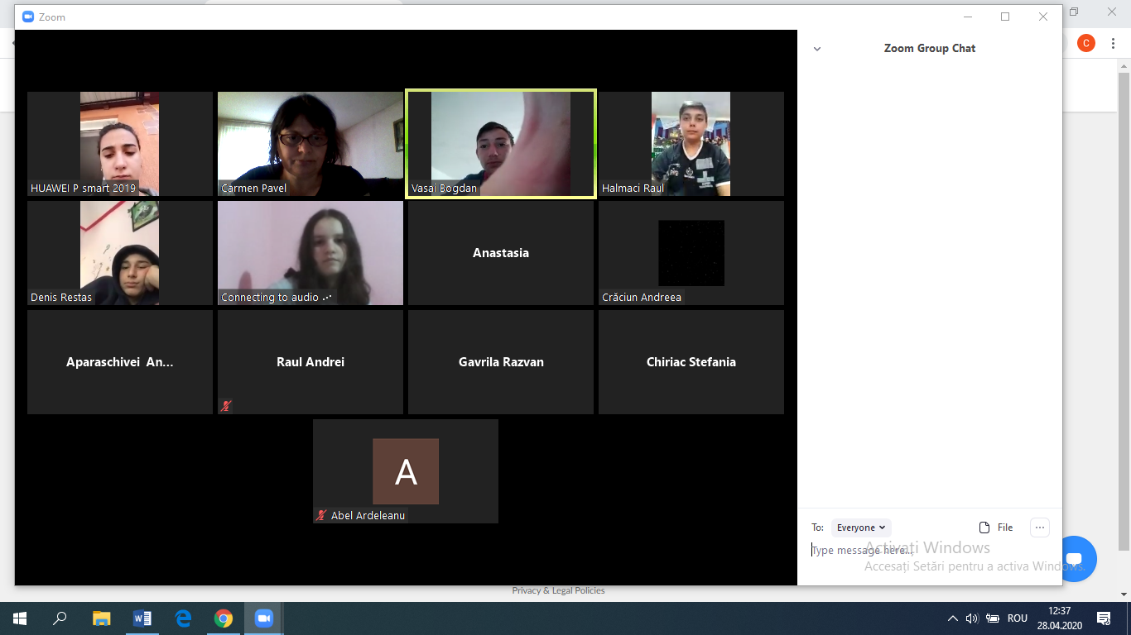

**4**.Carmen Pavel is inviting you to a scheduled Zoom meeting.

Topic: Educație tehnologică clasa a VIII-a B-Piața Muncii

Time: Apr 29, 2020 02:00 PM Bucharest

Join Zoom Meeting

[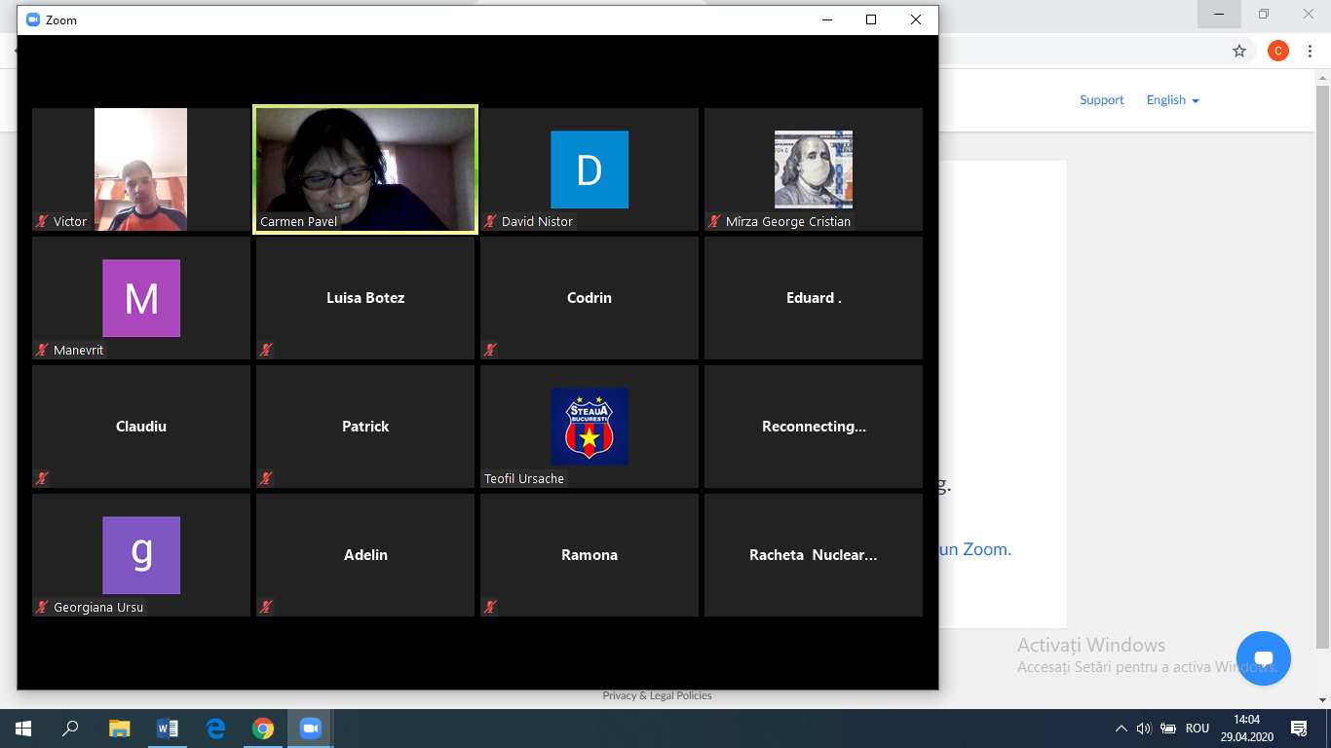](https://us04web.zoom.us/j/74416942306)

